Cash Book (Receipts / Payments / Summary)
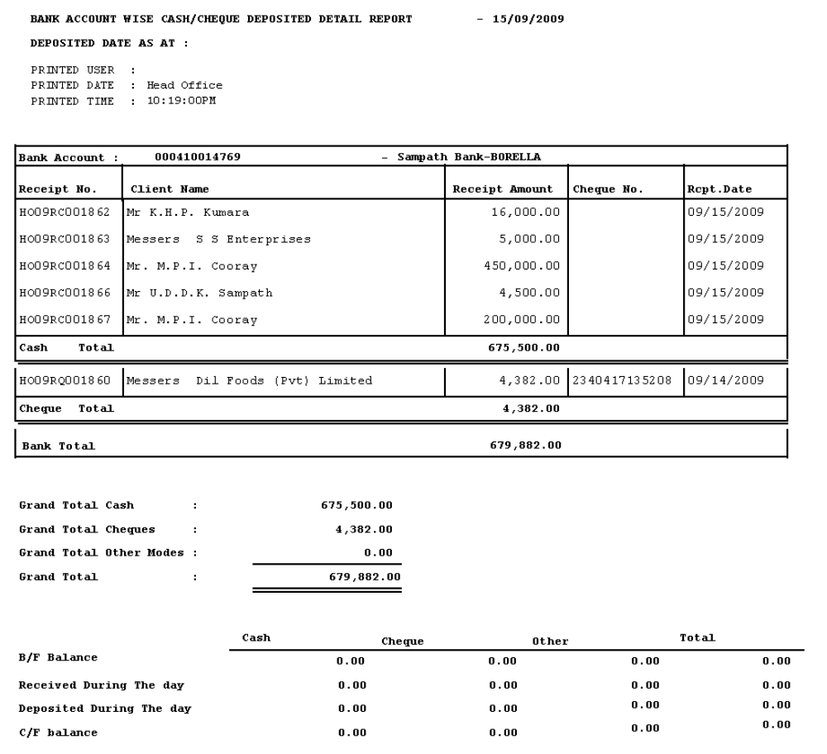

Collection Report

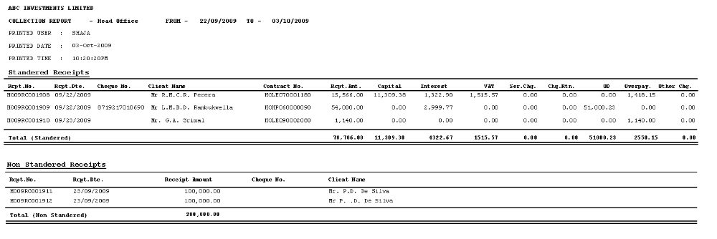

Tax Invoice
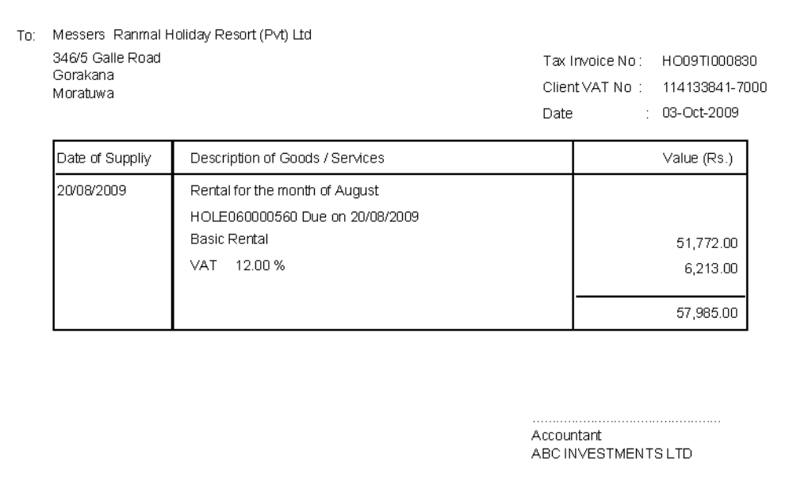

Cashier wise Collection Report
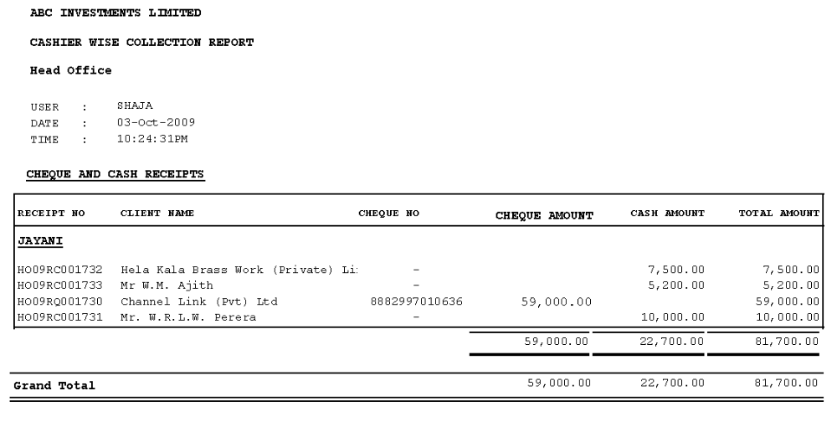

Petty Cash Book & Summary
Client Statements
Journals for a Given Periods
Collection Summary Ratio
Receipts Cancellation Listing
Cheque Return Statement

